- The diagram below incorrectly shows the life-cycle of a Dengue mosquito.

  - Redraw the diagram below with the four stages in the correct order. [3]

  - What is meant by a life-cycle? [1]

  - Is mosquito endangered? Answer yes or no. [1]

  - What will happen if mosquito did not have a
life-cycle? [1]
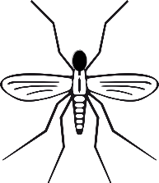

SOLUTIONS
Q1a:
Egg to Larva to Pupa to Adult and back to egg.

Q1b:
Living things come in to this world, they grow and produce more of their kind. This happens repeatedly and it is called life-cycle.

Q1c:
No.

Q1d:
Mosquitoes will become extinct.

