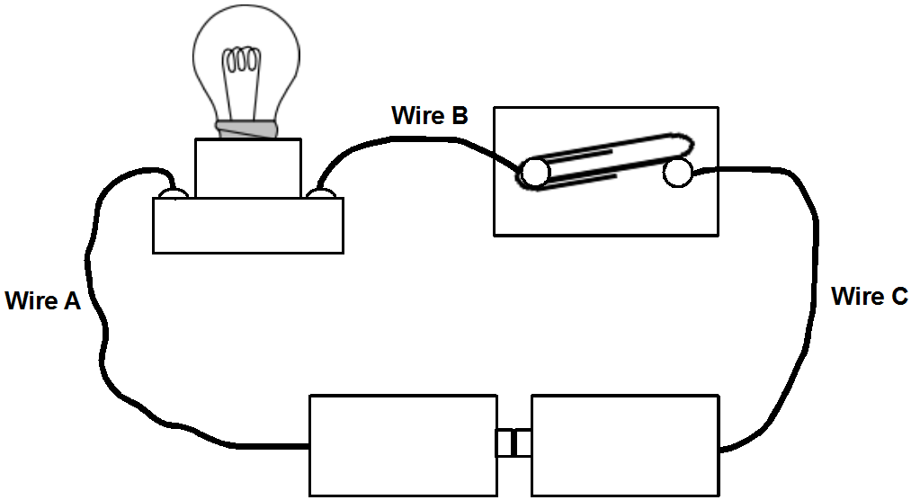

  - The bulb is not glowing. What is the problem? [1]

  - Draw a symbolic circuit diagram for the figure above with the problem fixed. [3]
  - After the circuit in part (a) has been fixed, a current of 1.5 A flows through the wire B. State the current that flows through wire C. [1]

SOLUTIONS
Q1a:
Polarity / arrangement of cells is incorrect.

Q1b:

OR

Q1c:
Same amount of current (1.5 A) will flow through wire C.

