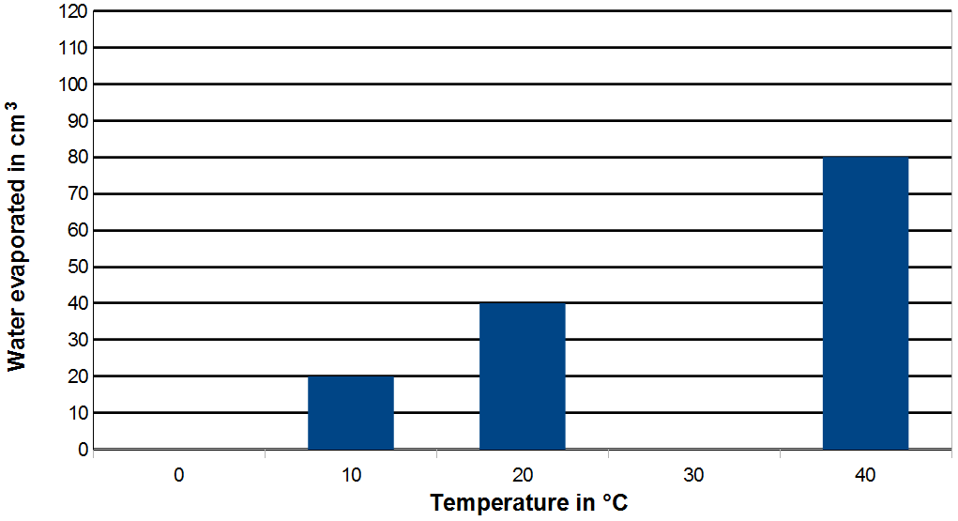
- In an experiment, five identical containers had water at different temperatures. The amount of water that evaporated from each of them was measured. As shown below, a graph was partially drawn. Study the graph and answer the following questions:
  - Why no water evaporated from the container at 0°C? [1]

  - How much water evaporated from the container at 20 °C? [1]

  - What is the temperature of the container from which 20 cm³ of water
evaporated? [1]

  - Carefully draw a (suggested) bar on the graph where the temperature is
30 °C. [1]
  - What is meant by evaporation? [1]

  - Write how evaporation is different from boiling. [1]

  - Name the process which can change the evaporated water back into a liquid. [1]

SOLUTIONS
Q1a:
It must be having frozen water and solids do not evaporate.

Q1b:
40cm³

Q1c:
10ºC

Q1d:
Bar drawn correctly.

Q1e:
Evaporation is the change of liquid at the surface into gas.

Q1f:
Unlike boiling, evaporation can happen at any temperature. Unlike boiling, evaporation does not produce bubbles. Evaporation is slower. Unlike boiling, evaporation only happens at the surface.

Q1g:
Condensation

