  - Label the heart by naming the four chambers. [4]
  - Two of the valves have been encircled. Show the direction of blood through these valves by drawing an arrow inside each circle. [2]
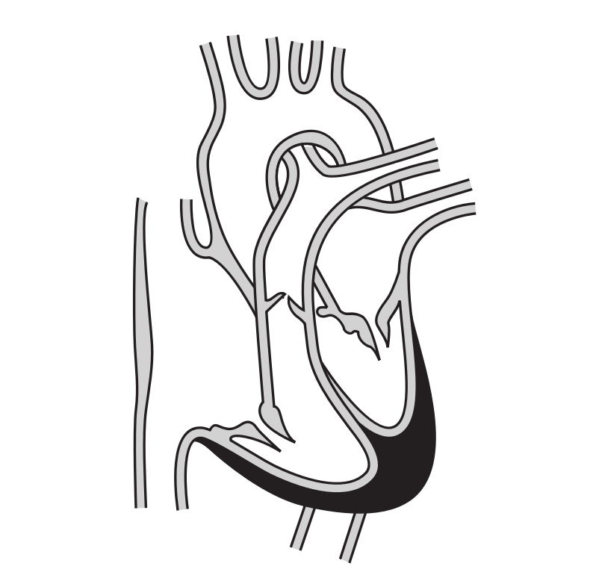
_______________
_______________
_______________
_______________

SOLUTIONS
Q1a:
Clockwise from top-right:
left atrium; left ventricle; right ventricle; right atrium

Q1b:
Arrow upwards in upper valve
Arrow towards bottom-right in lower valve

