- Look at the figure below and answer the following questions.
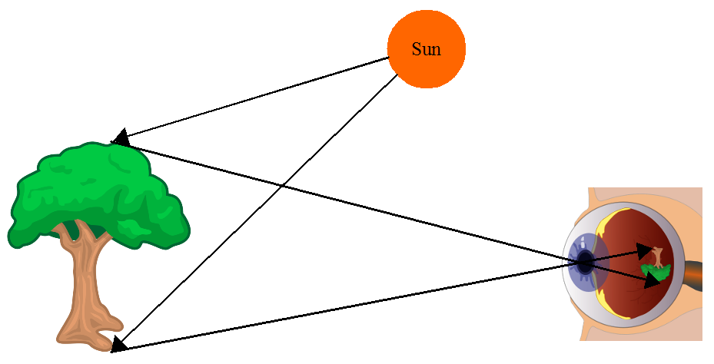
  - Explain what is happening in the figure above. Give all the details to score maximum marks. [4]

  - In the figure above, what is the [3]
Receiver of light: ___________________
Source of light: ___________________
Reflector of light: ___________________
SOLUTIONS
Q1a:
Light is produced by sun. It travels in straight lines. It travels at great speed. It is reflected by the tree. It goes to the eye. It enters the eye through a hole called pupil. An upside-down image of the tree is made on the retina (back of the eye). Light-sensitive cells there send signals (to the brain).

Q1b:
Eye
Sun
Tree
eye; sun; tree;

