- A teenager stands on a bathroom scale. The machine tells 50 kg.
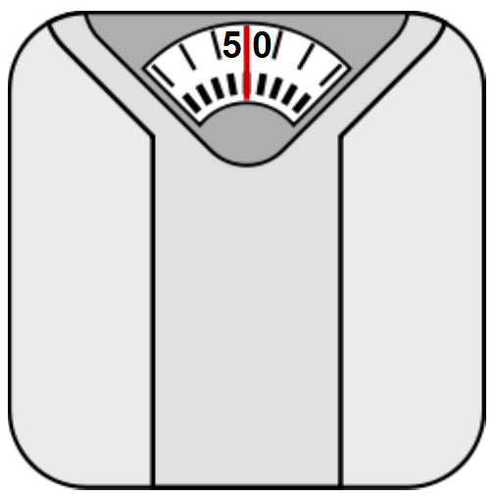
  - Calculate the weight of the teenager. [2]

  - There is a small swimming pool 5 m long and 2 m wide. When the teenager dived into it for a swim, the water level rose by 0.1 m. What is the volume occupied by the teenager. [2]

  - Now calculate the density of the teenager's body. Clearly write the formula that you use. [2]

  - Density of water in the swimming pool is 1000 kg/m³. The density of a leaf is 890 kg/m³. State whether the leaf will float or sink in the swimming pool? /1

SOLUTIONS
Q1a:
W = mg
W = 50 x 10
W = 500 N

Q1b:
Volume of the teenager is equal to the water displaced.
V = length x width x height
V = 5 x 2 x 0.1
V = 1 m³

Q1c:
Density = mass / volume
Density = 50 / 1
Density = 50 kg/m³

Q1d:
The leaf will float (because its density is less than that of water).
The leaf will float.

