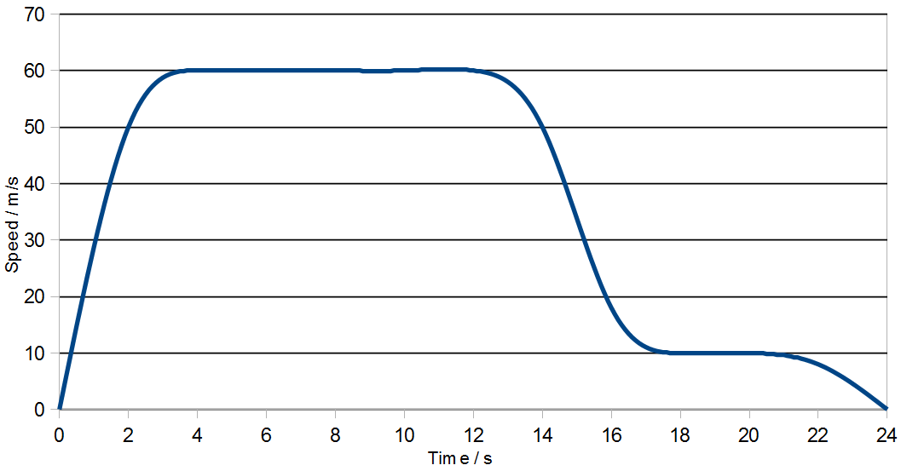
- Study this graph about the descent of a paratrooper and then answer the questions.
  - Name the two vertical forces acting on the paratrooper. [2]

  - Explain why the acceleration was greatest when he first jumped off the
plane? [1]

  - When did the paratrooper first begin to fall at terminal velocity? [1]

  - At what speed did he touch the ground? [1]

  - What will the graph look like if there was no upward force acting on the paratrooper? [1]

SOLUTIONS
Q1a:
Weight and Air resistance

Q1b:
According to Newton's second law, acceleration depends upon resultant force. Initially there was no air resistance to counter the weight. So resultant force downwards was maximum.

Q1c:
Any value between 3 to 5 seconds.
OR
When the speed became 60 m/s.

Q1d:
10 m/s

Q1e:
The graph would be a straight line (having positive gradient).
It would be a straight line (with a positive gradient showing constant acceleration).

