  - Label two parts of the stamen and three parts of the carpel. [5]
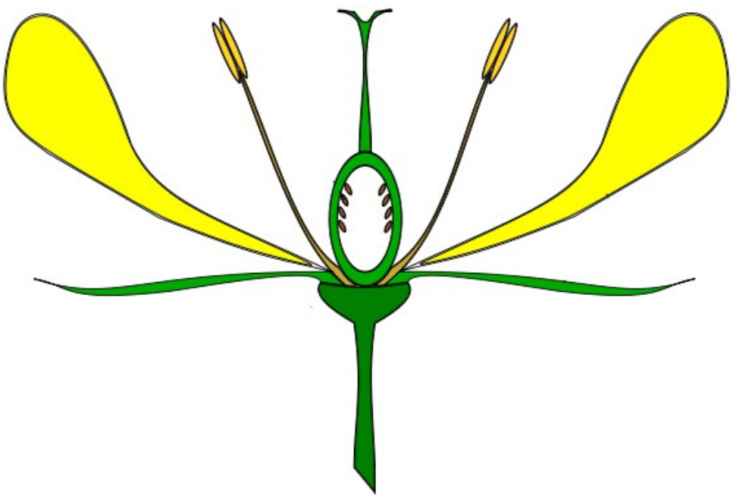
_______________
_______________
_______________
_______________
_______________
  - In which part of a flower are these found? [2]
Ovules:
Pollen:

SOLUTIONS
Q1a:
Clockwise from top-right: stigma; style; ovary; filament; anther;

Q1b:
Ovary
Anther

