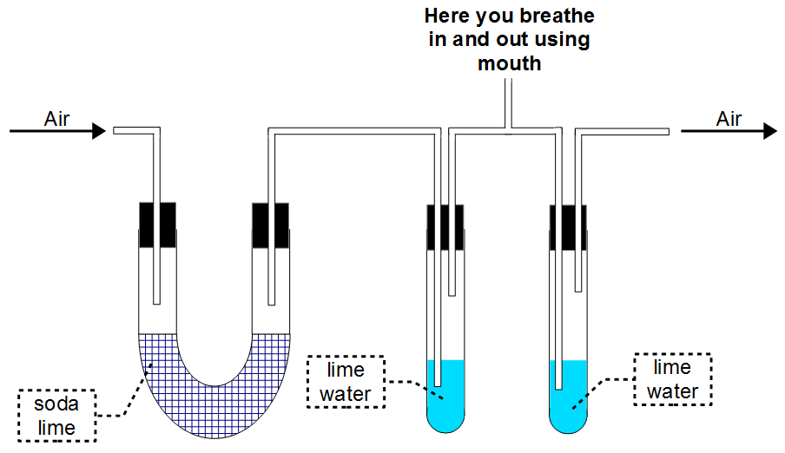
- The figure below shows an experiment.
  - What is the need for soda lime? [1]

  - What should happen to the limewater in the left boiling-tube when you breathe in? [1]

  - When you breathe out, which compound of calcium is produced in the boiling-tube on the right? [1]

  - What is this experiment trying to prove? [1]

  - Explain this statement: [2]
“Respiratory system supports respiration.”

SOLUTIONS
Q1a:
Sodalime absorbs carbon dioxide.

Q1b:
Nothing.

Q1c:
Calcium carbonate

Q1d:
Carbon dioxide is produced in our body (due to respiration).

Q1e:
Respiration is a chemical reaction that happens in all cells. This chemical reaction needs oxygen.
This oxygen is taken from the air by the respiratory system (which is made up of lungs, trachea, etc.)

